Hysterically Hadley

1000 words

Hi i'm Hadley but people around here call me Hysterically Hadley because i'm kinda crazy. I have about let's see here i have 2 best friends one of them is named is Sammie we go to school together at the SA super academy it's a boarding school for kids with superpowers, you're probably wondering what my superpowers are so number 1 i can fly and number 2 the one that got me named hysterically hadley whenever i'm hungry I can somon cheese I now i’m super weird. Sammie and I are roommates and were in 7th grade .My best friend can see anyone or anything (so don't try to keep a secret from her). I also have another best friend whose name is Ellie. I don't see her much because we're in different classes but we all sit together at lunch. She doesn't have a roommate but since she can teleport she sometimes comes to mine and sammies room. School gets out at 4:30 well we go into free time because it's a boarding school. People probably think it would be super cool to see Superman but I see him every day. He's my math teacher and the librarian is Wonder woman. I Love to prank people, especially Sammie and Ellie. When Sammie is at soccer and Ellie is working on an art piece I don't have anyone to play with. Which for Some people is great, but not me. I'm terrible at being by myself, and I can't call my family. So I am always bored. Sometimes I have to make my own fun so I just kinda sleep or throw my unicorn stuffed animal. 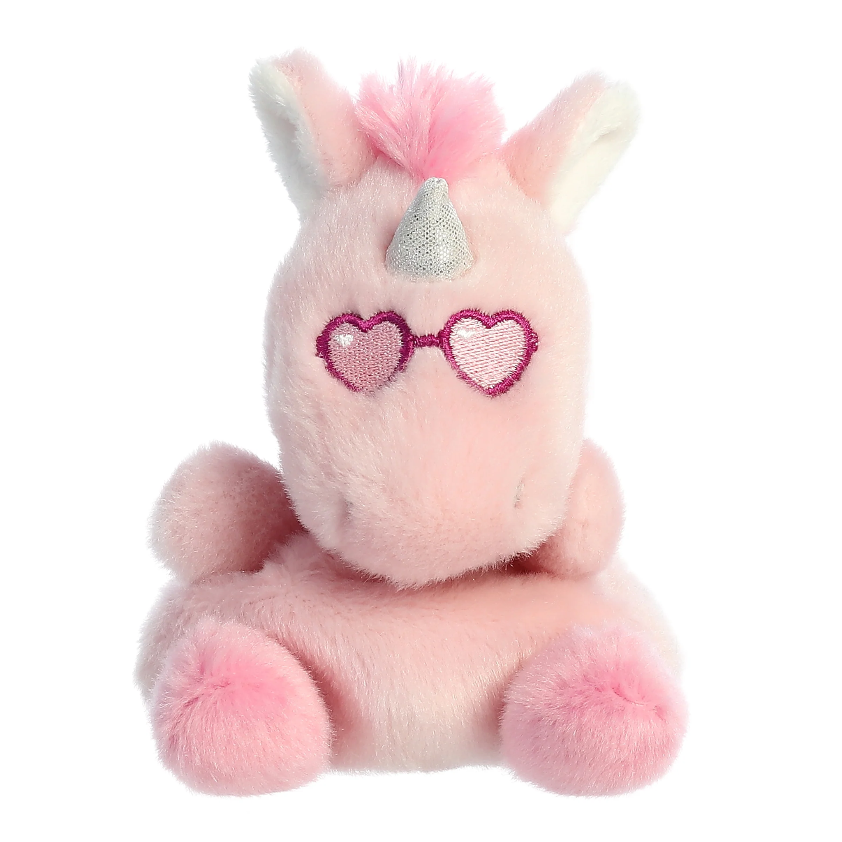 His name is Bill. I got him when I was 7 years old. I can't wait to go out tonight with Ellie and Sammie were going to an underwater party. I technically don't have a driver's license but I have a student license. So of course I need to put it to good use. On the way to math Sammie tells us let's drive the flying golf cart. Of course I say I'll drive. LATER THAT NIGHT. Shh i'm trying to sneak out to the party. It's 2:00 am we go through the halls and finally get to the party. We're here for over 2 hours then the principal comes, luckily Ellie teleports us back to the dorms before she can see us. Some of the other kids came to the party and they all got detention. Which would be very bad because if I got detention. And if my parents figured out I would properly get in trouble on visitors day. Well anyways good night! Good morning (yawn) for some reason Sammie isn't here. It's 7:30 SO l need to get dressed. Wait, it's 7:30!? Class starts at 7:15! Bye, I've got to get to class. Sorry for the rush, earlier it's lunch time now. I have macaroni and cheese with extra cheese and a strawberry smoothie. Sense were superheroes or superheroes in the making, We all have to eat this weird powder so we don't lose our powers. And yes in case you were wondering: IT'S ABSOLUTELY DISGUSTING! But I would rather eat that nasty stuff than lose my powers. I think we all would. Ellie starts talking about her new art piece so I can eat. I'm so excited to see her art. It's always so cool. DING! That's the bell, time for history. History goes very fast. Maybe it's because I'm excited, not for history but for after, because I get to the library. I have this book I get to pick up, it's about superheroes' favorite recipes.

After the library I am going to get my nails done, it's kinda annoying because I have to act like a regular 7th grade girl and not a superhero. Which doesn't sound hard except I can't fly inside and if I did people would probably sound something like this: ooh, ah, wow, so cool, oh my goodness and hey you can't do that! And if it was a superhero nail salon they would be like: oh hey hadley, what color do you want. Anyways, I hear someone calling me, hadley hadley HADLEY!!! When I come back to reality the whole class is laughing at me. The teacher obviously asked me a question. Hadley one more time, what was the first superhero? Oh yes it was phantom. Correct. Can anyone tell me who the most recent super hero is? My hand shoots up in the air without me noticing. Yes, the teacher sounds surprised, it is Kahhori. DING! That's the bell. I am tired and emotionless until I remember to go to the library. In the library I talk to wonder women for a lot longer than I intended. By the way, my nail appointment is in 5 minutes. She ushers me off because she loves her nails too. AT THE NAIL SALON. Hi yes i would like Hot pink, Neon green and pastel yellow. Hello, I'm here at the nail salon. She said it would take 1 hour. 1 hour later and my nails are done. I say thanks and pay as fast as I can because I want to go back to being myself. BACK AT THE DORM. I’m bored because sammies are hanging out with aspen and Ellie says she can't concentrate when I'm there. So i'm humming a song and I guess I was so distracted I didn't realize when some of the 5th graders came in I quickly snap back to reality to find them giggling I tell them you really thought i didn't know about this “prank” i’m the prank queen stuff like that gets around the school. But this time i'll be fine with it because there are my little friends. I’m the kind of girl who's best friends with 4th, 5th and 6th graders and Sammie is the kind of girl who's scared of them. Anyways, GOOD NIGHT.